Conceptual Class Diagram

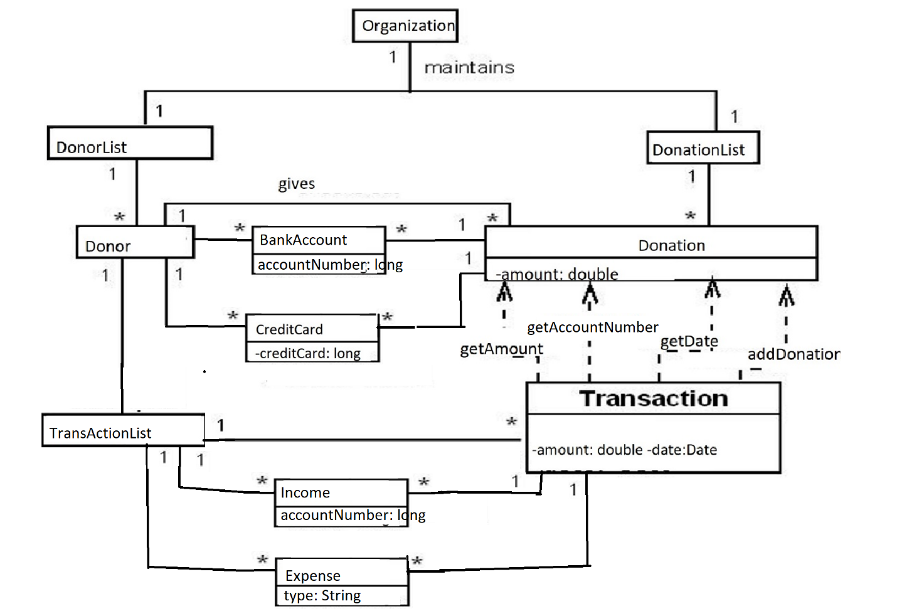

Sequence Diagram #6 Remove Bank Account

Sequene Diagram #7 Add Expense(s)

Sequence Diagram #8 List Organization Info

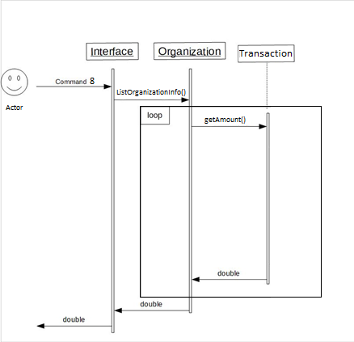

Sequence Diagram #9 List Payment Method Info()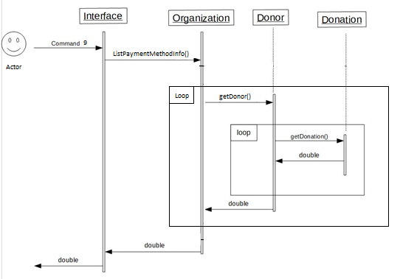

Sequence Diagram #10 List Expenses

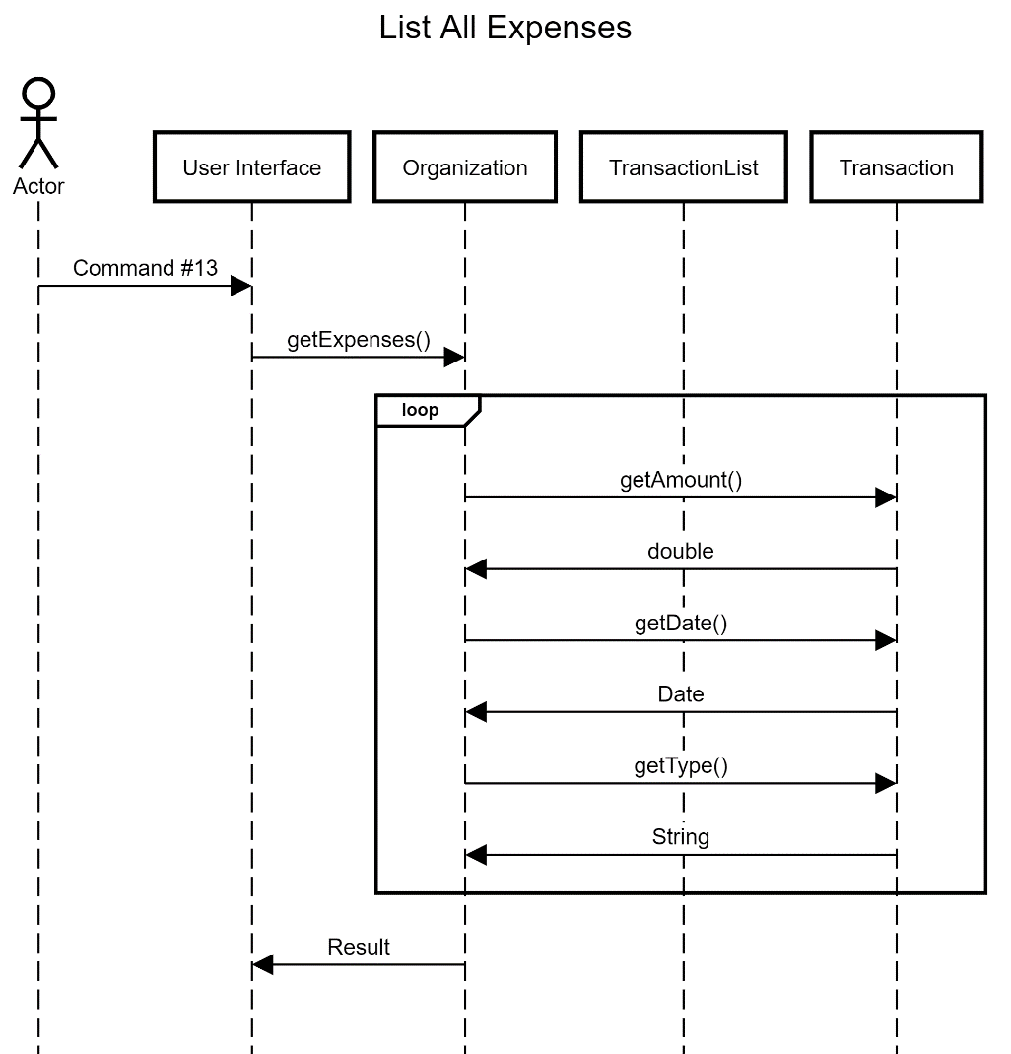

Physical Class Relationship Diagram